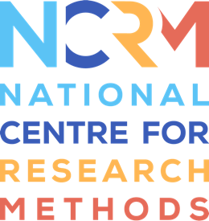
Generative AI Tools for Quantitative Research

Image description for accessibility

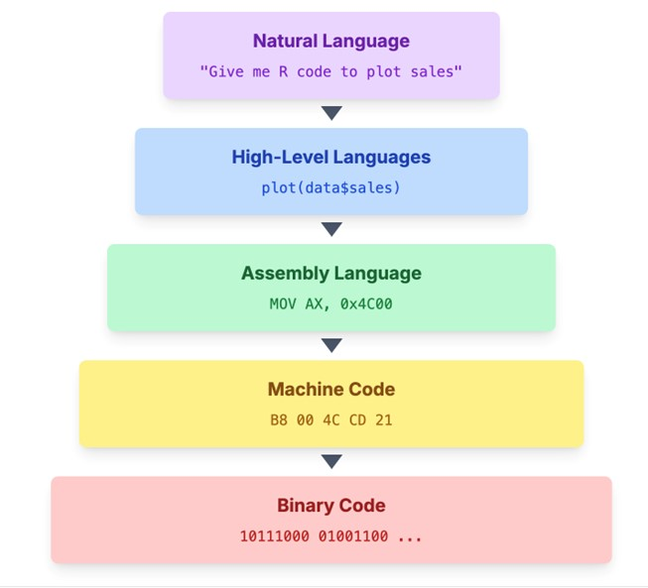

The image illustrates the hierarchy of programming languages and their translations down to binary code. It consists of five horizontal rectangles stacked vertically, each representing a different level of programming language. At the top, a lavender rectangle labelled "Natural Language" contains the text "Give me R code to plot sales." Below it, a light blue rectangle labelled "High-Level Languages" includes the text "plot(data$sales)." The third layer is a light green rectangle labelled "Assembly Language" accompanied by "MOV AX, 0x4C00." The fourth layer features a light yellow rectangle with "Machine Code" and "B8 00 4C CD 21." Finally, at the bottom, a pink rectangle labelled "Binary Code" displays "10111000 01001100 ..." Each rectangle has a downward-pointing arrow indicating the translation from one language to the next.

See full resource: https://www.ncrm.ac.uk/resources/online/all/?id=20859
National Centre for Research Methods (NCRM)
Social Sciences
Murray Building (Bldg 58)
University of Southampton
Southampton SO17 1BJ
United Kingdom
Web www.ncrm.ac.uk
Email info@ncrm.ac.uk
Tel +44 23 8059 4539
Twitter @NCRMUK

